COS20019
Cloud Computing Architechture
Truong Ngoc Gia Hieu
105565520
Challenge Lab: Creating a Dynamic Website for the Cafe
A. Scenario

After the café launched the first version of its website, customers told the café staff how nice the website looks. However, in addition to the providing praise, customers often asked whether they could place online orders.

Sofía, Nikhil, Frank, and Martha discussed the situation. They agreed that their business strategy and decisions should focus on delighting their customers and providing them with the best possible café experience.

B. Lab overview and objectives

In this lab, you deploy an application on an Amazon Elastic Compute Cloud (Amazon EC2) instance. The application gives the café the ability to accept online orders. After testing that the application works as intended in the first AWS Region (the development environment), you then create an Amazon Machine Image (AMI) from the EC2 instance. You also deploy a second instance of the same application as the production environment in another AWS Region.

After completing this lab, you should be able to do the following:
- Connect to the AWS Cloud9 integrated development environment (IDE) on an existing EC2 instance.
- Analyze the EC2 instance environment and confirm web server accessibility.
- Install a web application on an EC2 instance that also uses AWS Secrets Manager.
- Test the web application.
- Create an AMI.
- Deploy a second copy of the web application to another AWS Region.

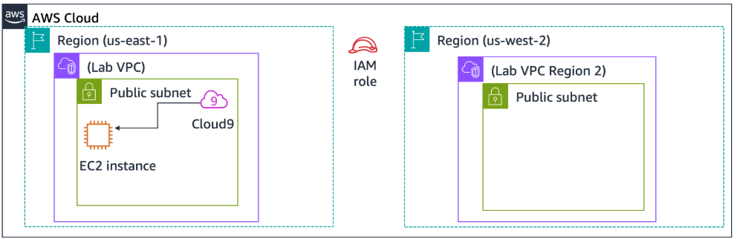
When you start the lab, some resources are already created for you in the AWS account:

At the end of this lab, your architecture should look like the following example:

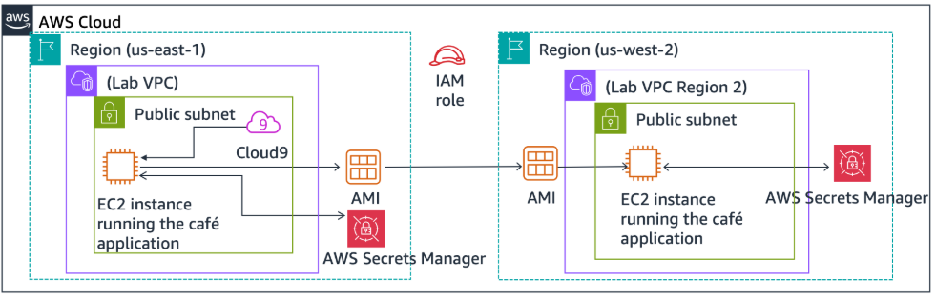
Duration
This lab requires approximately 60 minutes to complete.

AWS service restrictions
In this lab environment, access to AWS services and service actions might be restricted to the ones that are needed to complete the lab instructions. You might encounter errors if you attempt to access other services or perform actions beyond the ones that are described in this lab.

C. Accessing the AWS Management Console
To access the AWS Management Console, click on the button Start Lab and wait until the circle next to the AWS turns from red to green
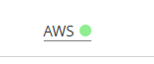

Figure 1: AWS Activated

D. TASK 1: Analyzing the existing EC2 instance
In this task, you note details about an existing EC2 instance that has been created for you in the AWS account.

Step 1.1: On the AWS Management Console, in the search box, enter and choose EC2 to open the Amazon EC2 console.
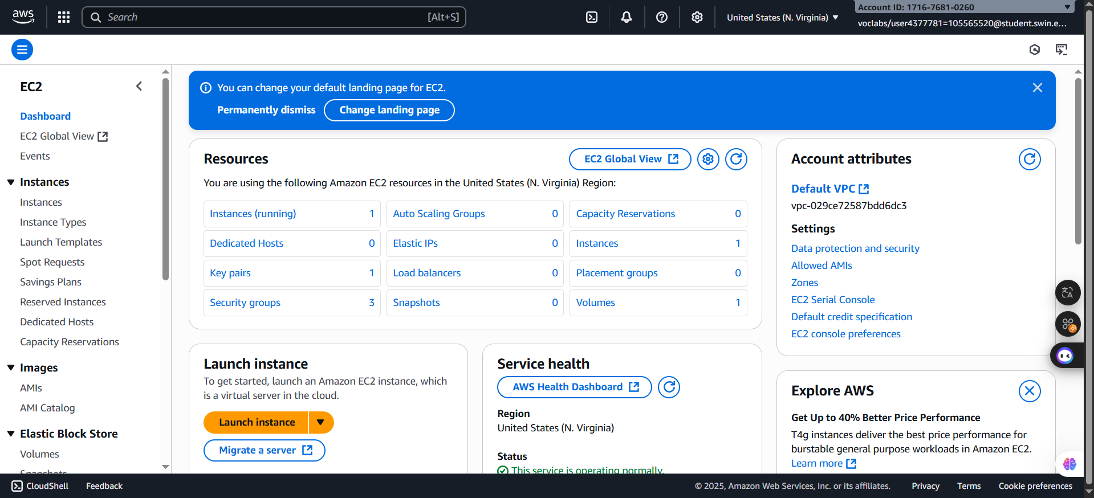
Figure 2: EC2 Console page

Step 1.2: Choose Instances.
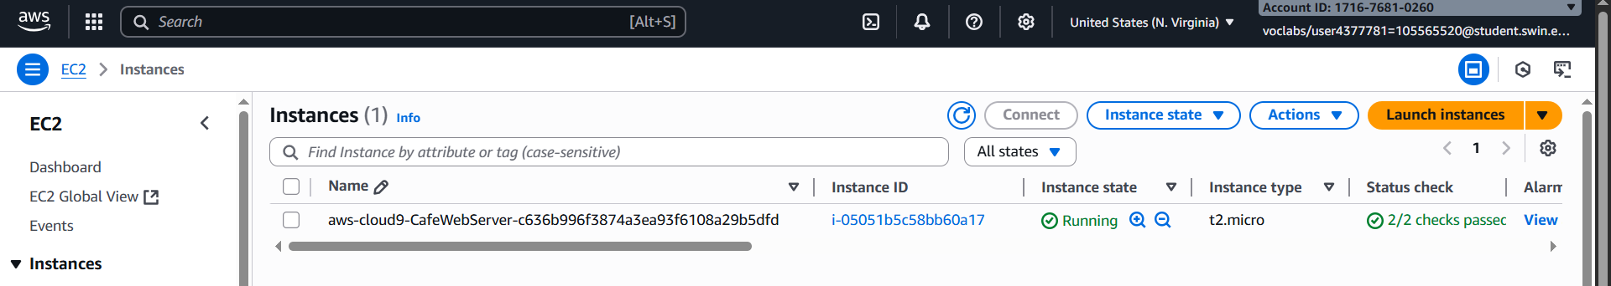
Notice the running instance named aws-cloud9-CafeWebServer-.... This EC2 instance was created when you started the lab.
Figure 3: Instance running

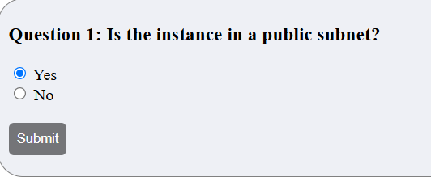
Step 1.3: Answer first question
Figure 4: First question
From my perspective, the answer for the first question is Yes because when choosing the instance itself and select the Networking tag, it showcases the Subnet ID

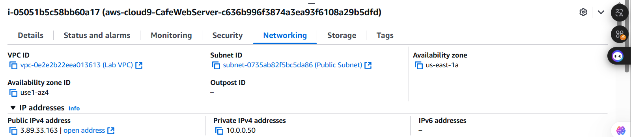
Figure 5: Networking tag

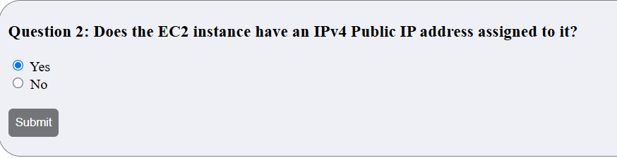
Step 1.4: Answer question 2
Figure 6: Second question

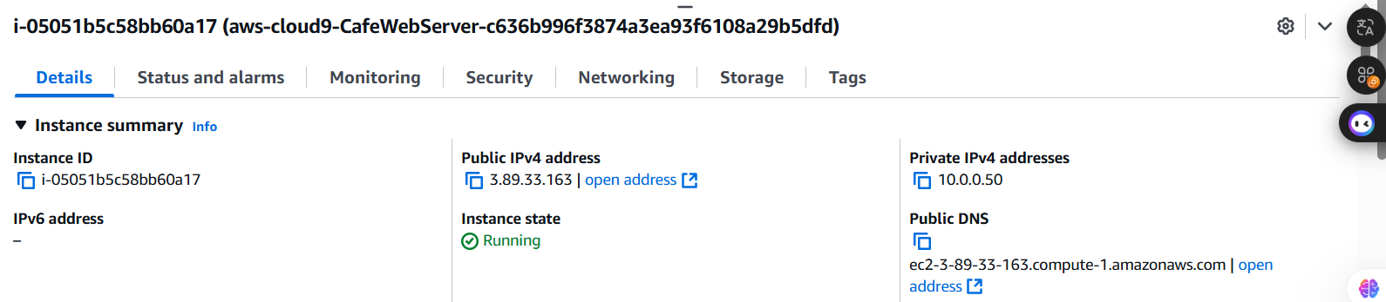
Based on the Details tag, the insatnce has an IPv4 Public IP address

Figure 7: Details tag

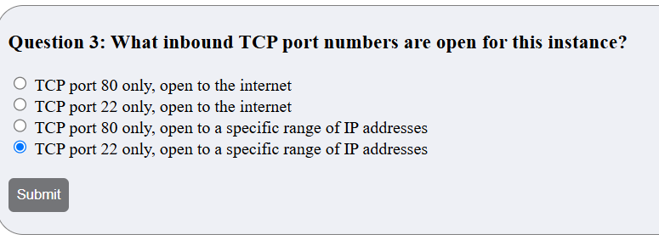
Step 1.5: Answer question 3
Figure 8: Third question
After clicking on the Security tags, I see Protocol is set as TCP
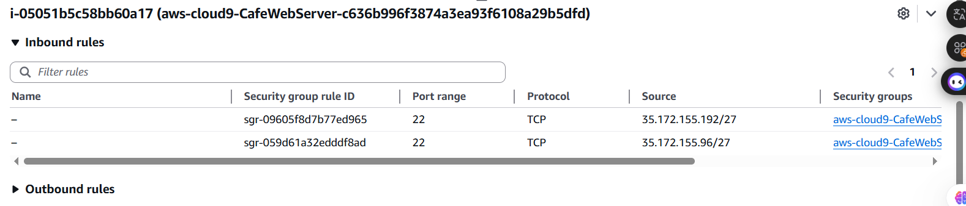
Figure 9: Security tag

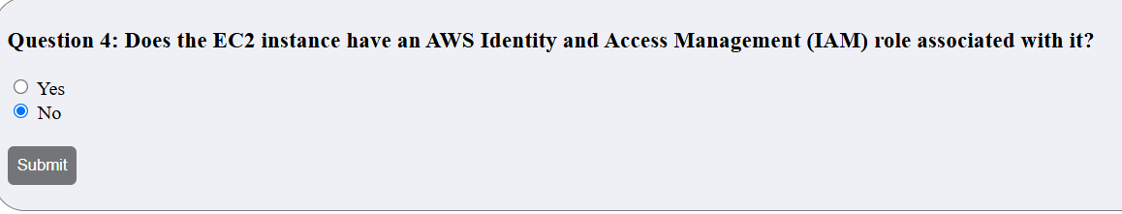
Step 1.6: Answer question 4

Figure 10: Fourth question

E. TASK 2: Connecting to the IDE on the EC2 instance

AWS Cloud9 is service that can run on an EC2 instance. It provides an IDE that includes features such as a code editor, debugger, and terminal.

By using the AWS Cloud9 IDE, you don't need to download a key pair and connect to the EC2 instance by using PuTTY or similar Secure Shell (SSH) software. By using AWS Cloud9, you also don't need to use command line text-editing tools (such as vi or nano) to edit files on the Linux instance.

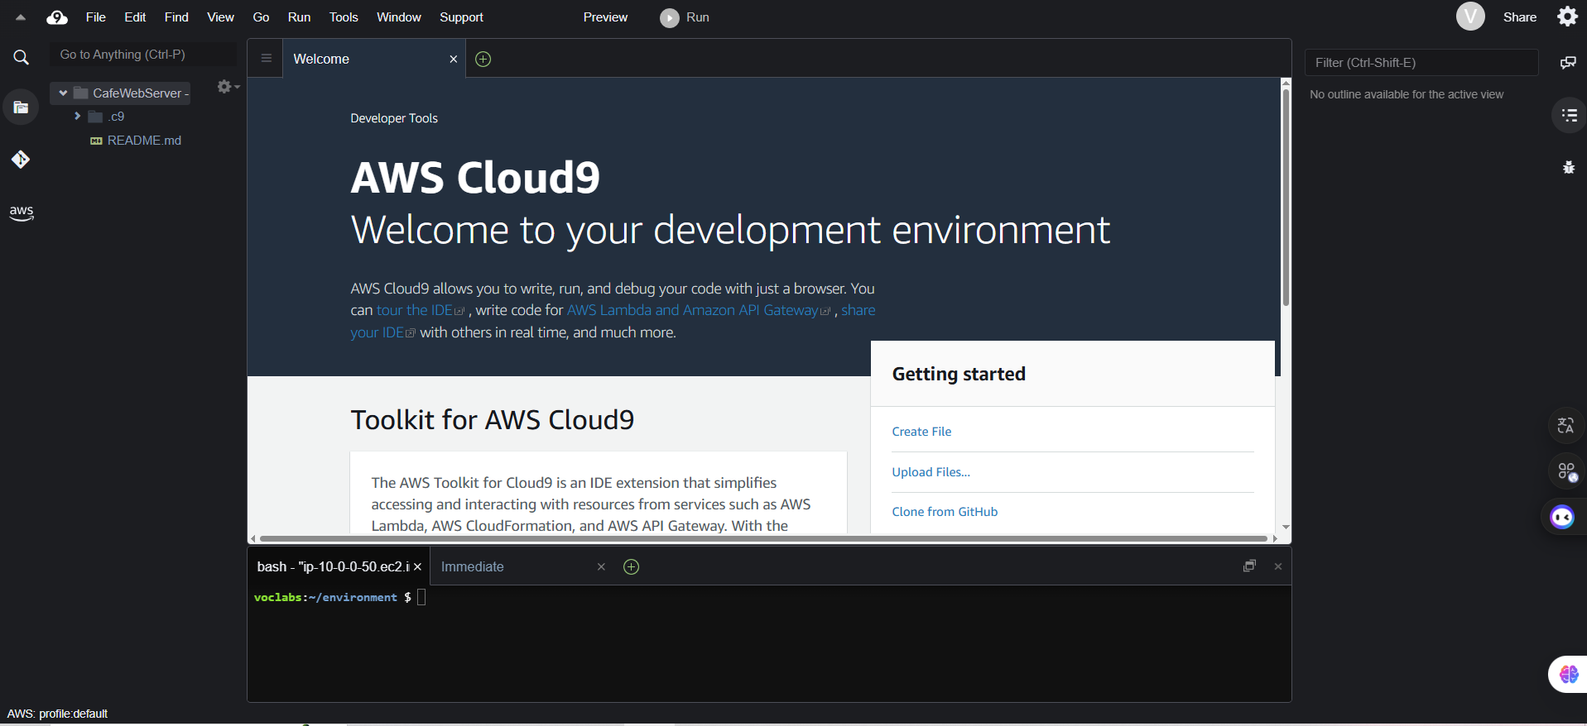
Step 2.1: On the browser tab with these instructions, from the AWS Details window, copy the value for Cloud9url, and paste it into a new browser tab to open the AWS Cloud9 console.
Figure 11: Cloud9url result
F. TASK 3: Analyzing the LAMP stack environment and confirming that the web server is accessible

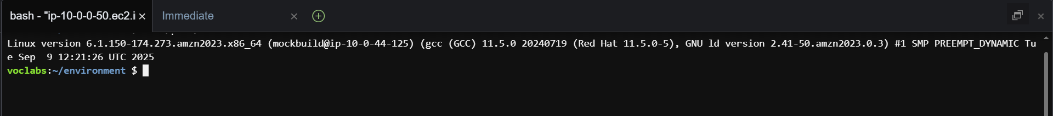
Step 3.1: To observe the operating system version, in the AWS Cloud9 bash terminal, run the following command: “cat /proc/version”

Figure 12: Version Configuration

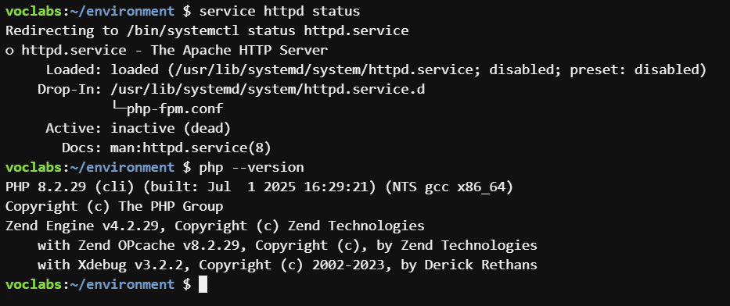
Step 3.2: To observe the web server, PHP details, and server state, run the following commands:
Figure 12: PHP Details and Server state Configuration

Step 3.3: To start the web server, install the database, and set them to start automatically after any future EC2 instance restarts, run the following commands:
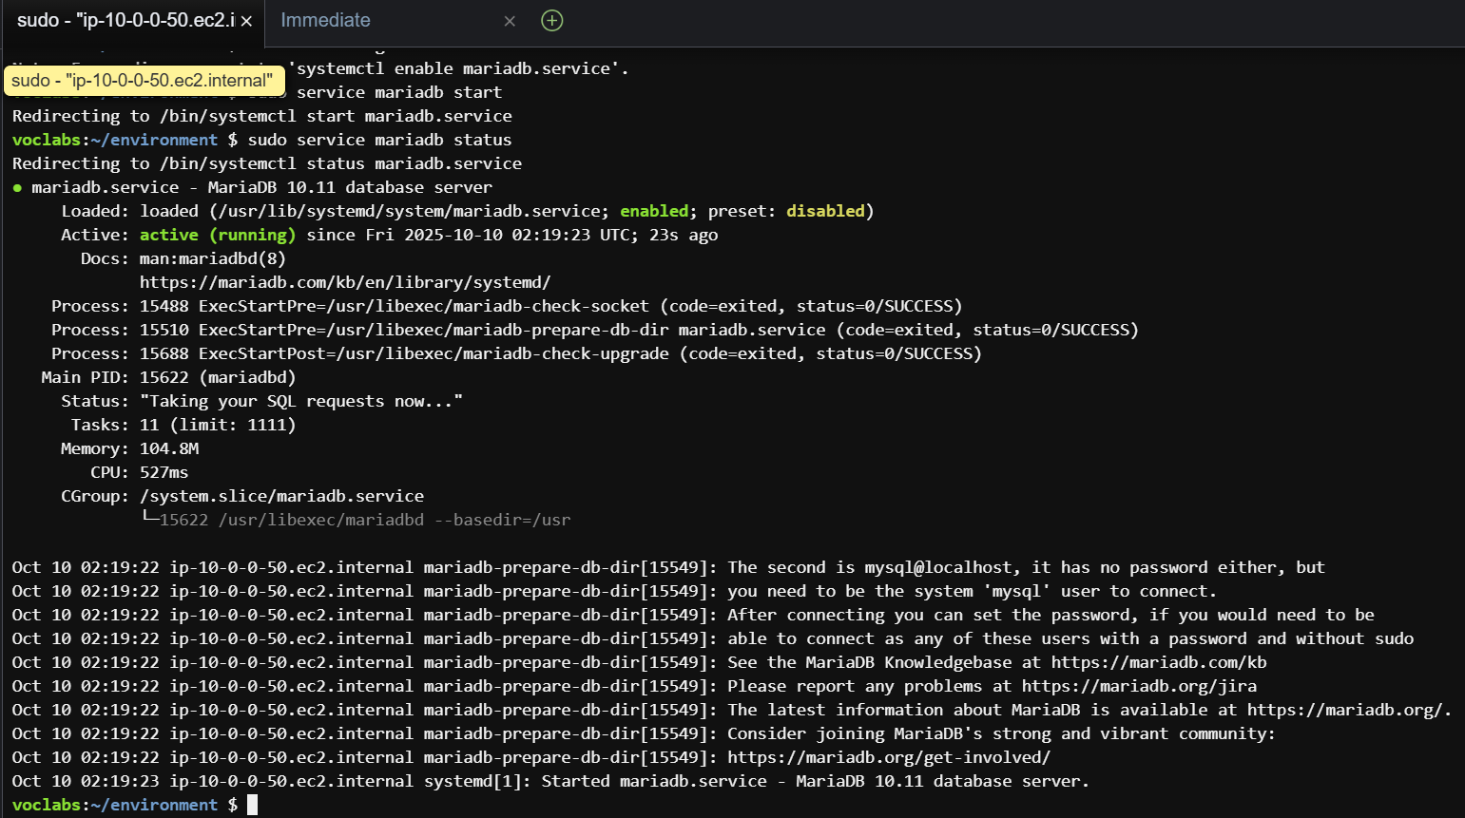
Figure 13: Web Server Started Configuration

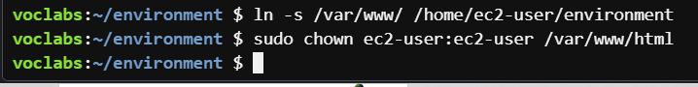
Step 3.4: To configure the EC2 instance so that you can use the AWS Cloud9 editor to edit web server files, run the following commands:
Figure 14: EC2 Configuration

Step 3.5: In the file browser, expand the CafeWebServer > www directory, and choose the html directory.
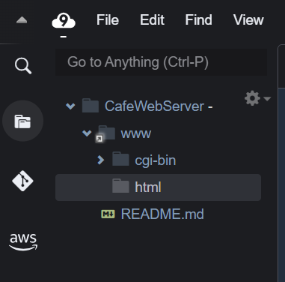

Figure 15: Structure configuration

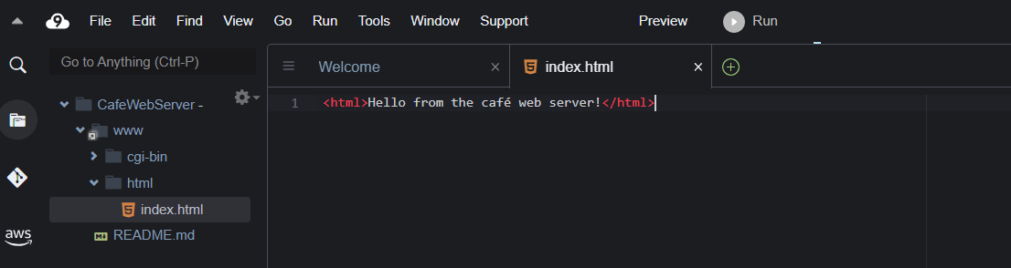
Step 3.6: In the folder html, create new file named index.html and paste the code into its file
Figure 16: Code configuration

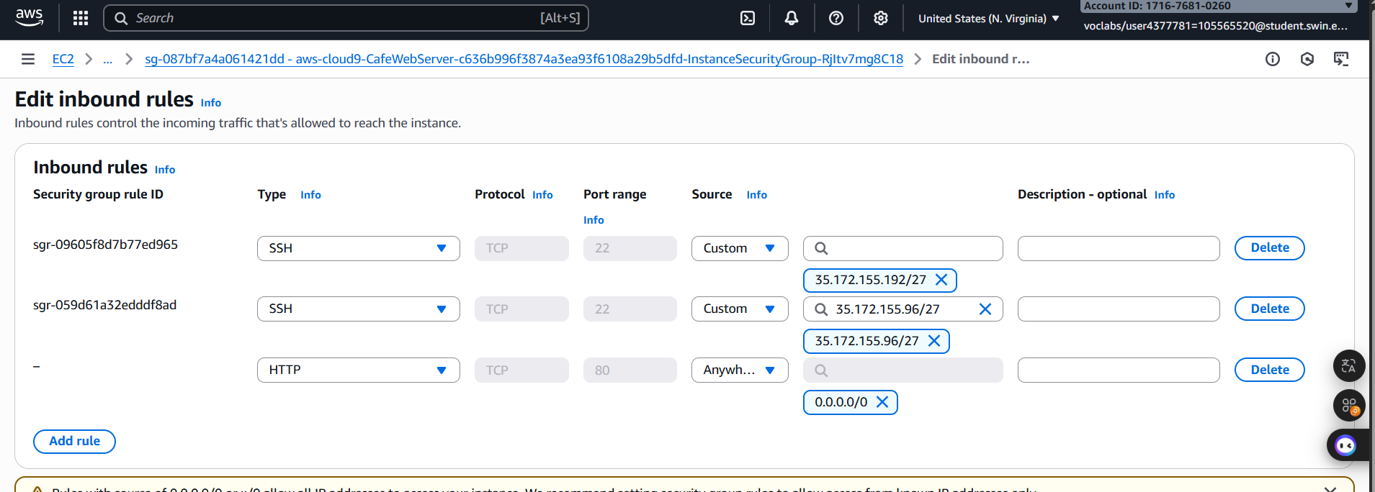
Step 3.7: Then, in the EC2, choose the instance to edit the Inbound rules

Figure 17: Inbound configuration

Step 3.8: Next, paste the pulic IP address to new tab

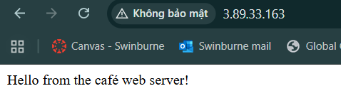

Figure 18: Pulic link configuration

G. TASK 4: Installing the café application
Step 4.1: To download and extract the web server application files, run the following commands:

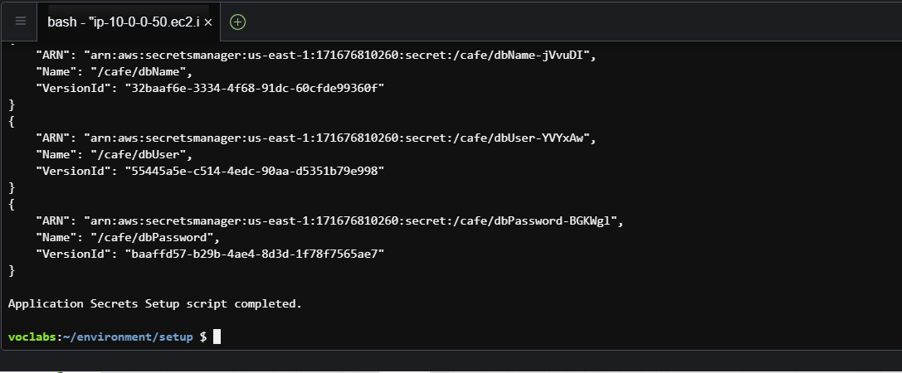
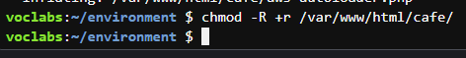
Figure 19: Install Configuration
Figure 20: Install successfully

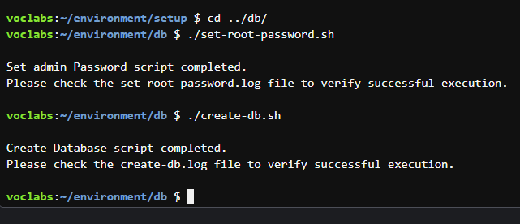
Step 4.2: To configure the MySQL database to support the café application, in the AWS Cloud9 bash terminal, run the following commands:
Figure 21: Configure successfully

Step 4.3: To connect the terminal-based MySQL client to the database, run the following command:”mysql -u admin -p”. Then, paste the password
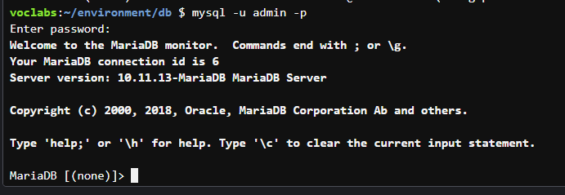

Figure 22: Password login successfully

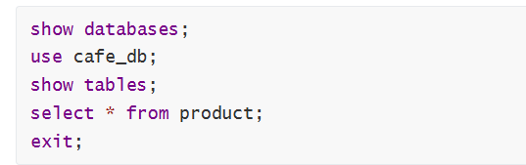
Step 4.4: To observe the contents of the database (specifically, the tables that support the café web application), run the following commands:
Figure 23: Command lines
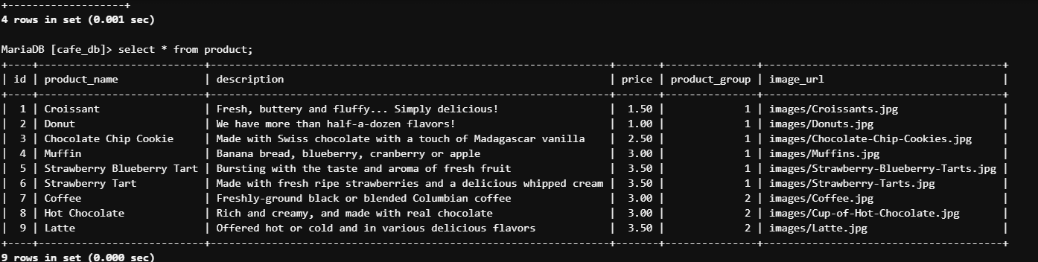
Figure 24: Command Configuration

Step 4.5: To update the time zone configuration in PHP, in the bash terminal, run the following commands:
Figure 25: Command Lines

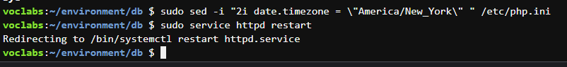

Figure 26: Command Configuration

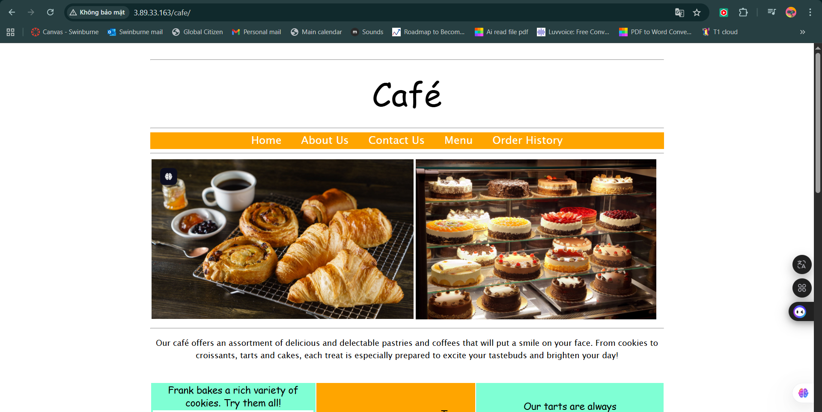
Step 4.6: To test whether the café website is working and can be accessed from the internet, in a new browser tab, enter http://<public-ip>/cafe and replace <public-ip> with the public IPv4 address of the EC2 instance.

Figure 27: Launch web successfully

Step 4.7: Select the IAM Role
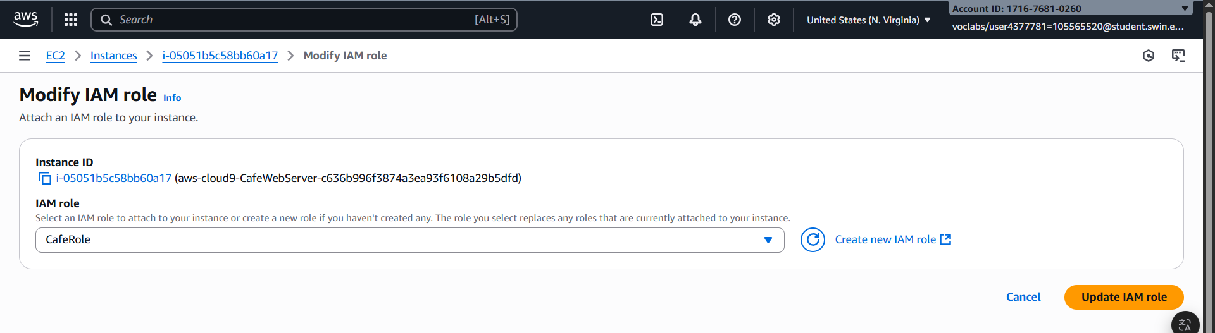
Figure 28: AMI Configuration

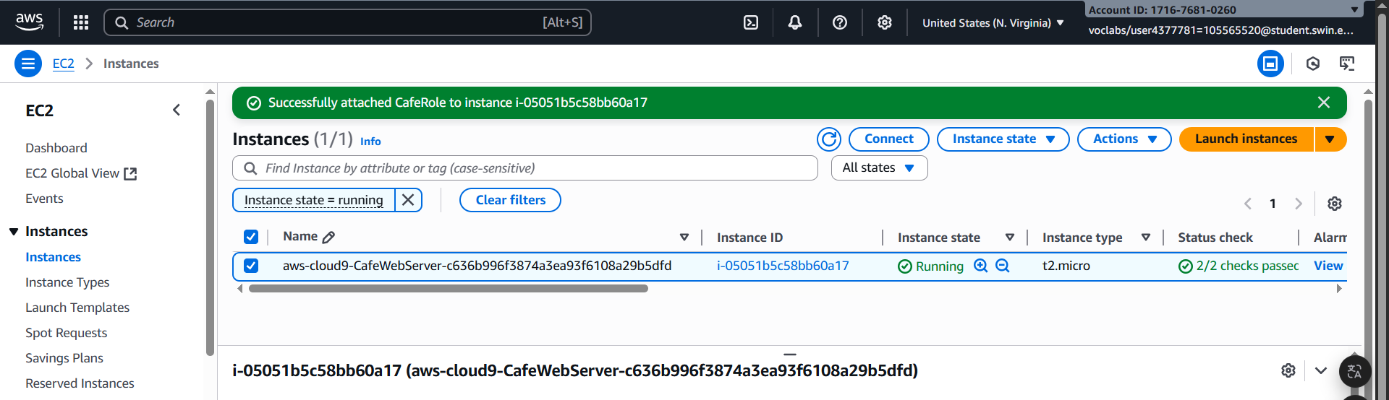
Figure 29: AMI Configure successfully

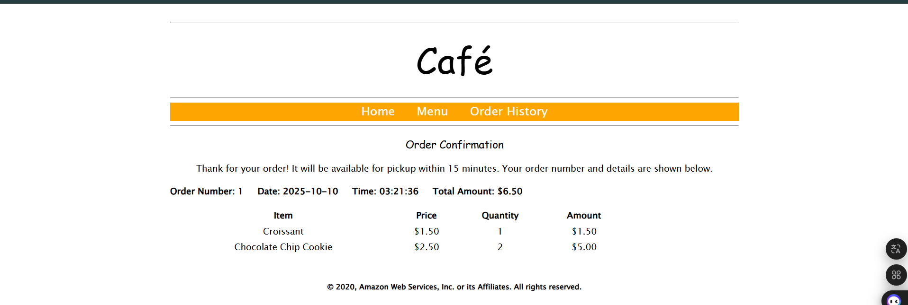
H. TASK 5: Testing the web application

Figure 30: Order successfully

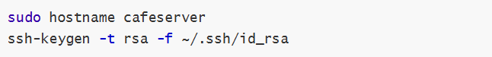
Step 5.1: To set a static internal hostname and create a new key pair on the EC2 instance, in the bash terminal, run the following commands, ensure that you are on prompt voclabs:~/environment $, if not , used cd ..

Figure 31: Command lines
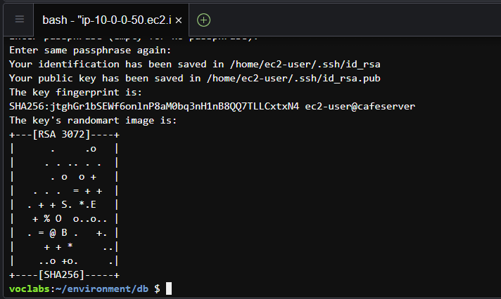

Figure 32: onfigure successfully

Step 5.2: To make the new key available to the SSH utilities, in the bash terminal, run the following command: ‘cat ~/.ssh/id_rsa.pub >> ~/.ssh/authorized_keys’

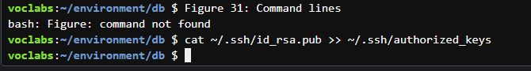
Figure 33: Configure successfully

I. TASK 6: Creating an AMI and launching another EC2 instance

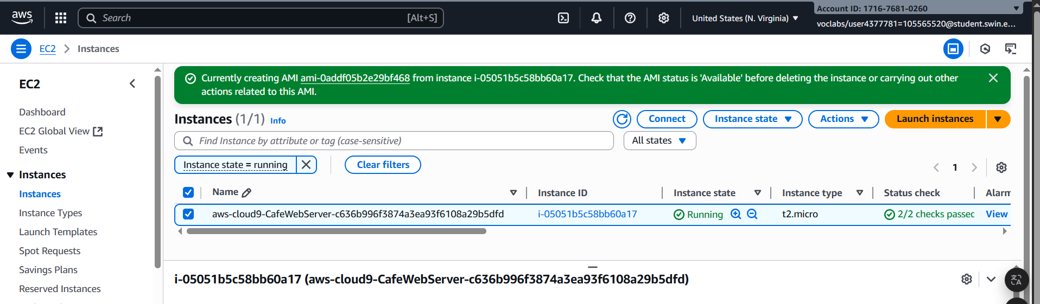
Step 6.1: On the Amazon EC2 console, in the Create Image page, for Image name, enter CafeServer.
Figure 34: AMI created successfully
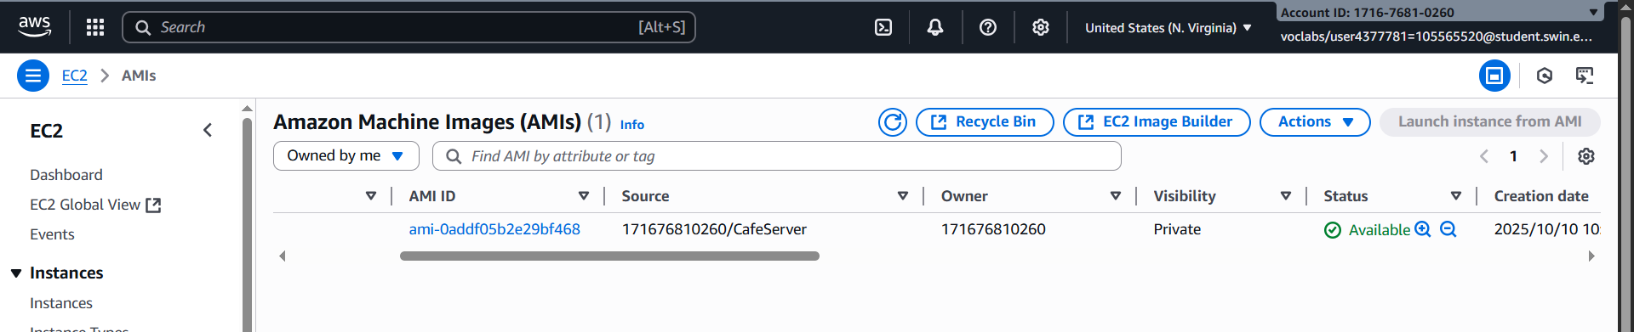

Figure 35: Available status check

